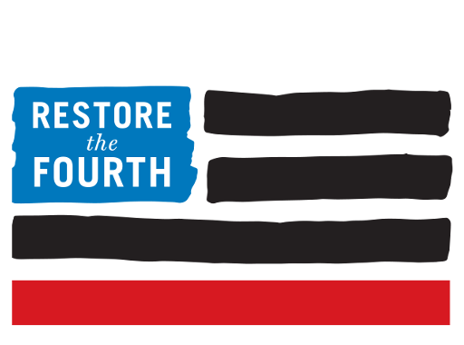

June 7, 2016

Santa Clara County Votes to Adopt Landmark Surveillance Technology Ordinance

San Jose, CA – Today, the Santa Clara County Board of Supervisors voted unanimously to adopt a Surveillance Technology Ordinance that requires any local law enforcement or county agency to get board approval prior to purchasing new surveillance technology or implementing new uses of existing technology. More broadly, the ordinance demands that agencies inventory, standardize, and publicly disclose their digital data collection systems as well as enforce safeguards governing data retention and access.

The ordinance adopted in Santa Clara is the first in the country to require:

1) Public debate and the institution of usage regulations before equipment is deployed.
2) Annual reporting on how the surveillance technologies are being used.
3) Criminal penalties when these regulations are intentionally violated.

The Santa Clara Sheriff Department’s controversial $500,000 purchase of a “Stingray” cell phone tracking device in February 2015 intensified efforts to introduce adequate oversight and accountability mechanisms’ regulating intrusive police surveillance tools that potentially infringe on citizens’ rights. The Board’s approval of the ordinance, described as one of the “one of the broadest anti-surveillance measures being considered anywhere in the US,” represents the culmination of several years of work by local and national civil liberties advocates.

Zaki Manian, chair of Restore the Fourth’s San Francisco Bay Area chapter, coordinated efforts – in collaboration with the ACLU Northern California and the Oakland Privacy Working Group –
to draft the model ordinance and lobby the Board of Supervisors to vote in favor of introducing the change. “We think that the passage of this law will introduce a firewall against the secret adoption of current and future surveillance technologies like mass biometric collection. Our next steps are to pass similar ordinances in communities across the country. The process has already started in Palo Alto, Oakland, Santa Cruz and Alameda. Today’s unanimous vote will massively accelerate the process,” says Manian.

Restore the Fourth is encouraged by Santa Clara County’s vote for transparency and community involvement in decisions around surveillance and civil liberties. We hope that Santa Clara’s Surveillance Technology Ordinance may also serve as a model for nationwide, locally-driven surveillance reform efforts which aim to strengthen privacy protections and improve policing practices.

Ordinance

Surveillance Technology Ordinance

Contacts

Alex Marthews
National Chair
Restore the Fourth
chair@restorethefourth.com

Zaki Manian
Chair
Restore the Fourth – San Francisco Bay Area Chapter
zaki@manian.org

Danielle Kerem
Communications Chair
Restore the Fourth
communications@restorethe4th.com

